Regional Council:
RVP Saskatchewan, Manitoba

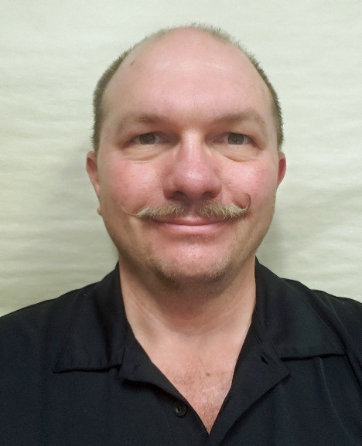
Alex Ethier Bio

Alex Ethier is the founder of I M Safe Inc., a consulting and training company based out of Winnipeg, Manitoba. Through his fifteen years of occupational safety experience, he has developed a "keep it simple" approach to safety focusing on training and helping everyone understand the "why" of safety. He holds CRST and NCSO designations.

He has served as the Manitoba/Saskatchewan RVP since December 2020, and served 1 year in the Manitoba Chapter as Secretary, 4 years as Chair, and other positions within the Chapter Executive. He has also served on national committees within the CSSE including the Communications Committee and Communications Task Force.

He is an instructor of numerous courses including First Aid, Psychological First Aid, WHMIS, TDG, Fall Protection among others. He has developed online, blended and classroom courses, and is a registered COR and SafeWork auditor in Manitoba.

Just for fun, he referees Beach and Indoor volleyball (as well as plays occasionally) and during the holiday season, he may be found handing out gifts or candy to children as Santa.

