Incident Number:

- Identify any potential Pre-Cursers * 2) Complete Contributing Factors Sheet (page 2)

TASK DEMANDS (TD) |  | INDIVIDUAL CAPABILIITES (IC)
TD1 – Time Pressure (rushing) |  | IC1 – Unfamiliarity with task / First Time
TD2 – High Workload (memory requirements) |  | IC2 – Lack of Knowledge (mental model)
TD3 – Simultaneous, Multiple Tasks |  | IC3 –New Techniques not used before
TD4 – Repetitive Actions / Monotony |  | IC4 – Imprecise communication habits
TD5 – Irreversible Actions |  | IC5 – Lack of proficiency / Inexperience
TD6 – Interpretation Requirements |  | IC6 – Unsystematic problem-solving skills
TD7 – Unclear goals, roles or responsibilities |  | IC7 – Illness or Fatigue
TD8 – Lack of or clear unclear standards

WORK ENVIRONMENT (WE) |  | HUMAN NATURE (HN)
WE1 – Distractions / Interruptions |  | HN1 – Stress
WE2 – Changes / Departures from routine |  | HN2 – Habit Patterns
WE3 – Confusing procedures / Vague guidance |  | HN3 –Assumptions Made
WE4 – Confusing Displays / Controls |  | HN4 – Complacency / Overconfidence
WE5 – Work Around / OOS instrumentation |  | HN5 – Mind Set (intention)
WE6 – Hidden System Response |  | HN6 – Inaccurate Risk perception
WE7 – Unexpected Equipment Conditions |  | HN7 – Mental shortcut (Biases)
WE8 – Lack of Proper Tools, Procedures, etc |  | HN8 – Limited Short-term memory

* Pre-curser is an unfavorable factor that can increase the chances of error during the performance of a specific task.

Did event involve issues with: | What was the issue? | Why did the issue occur?
Design or Construction | Design Input or Output not adequate  Design Documentation not adequate
Design Implementation / Verification
Operability of design / Environment
Material or Equipment | Calibration not adequate  Periodic maintenance not adequate  Inspection / Testing not adequate
Material Control not adequate
Procurement Control not adequate
Defective, failed or contaminated
Human Performance | Skill Based Error  Rule Based Error
Knowledge Based Error
Work Practices not adequate
Management Systems | Management Methods  Resource Management  Work Organization and Planning
Supervisory Methods
Change Management
Communication | Written communication not adequate  Communication content not adequate
Written communication not used
Verbal Communication not adequate
Training | No training provided  Training Methods not adequate  Training Material not adequate
Other Issues | External Phenomenon  No cause is applicable

Completed by: | Date:

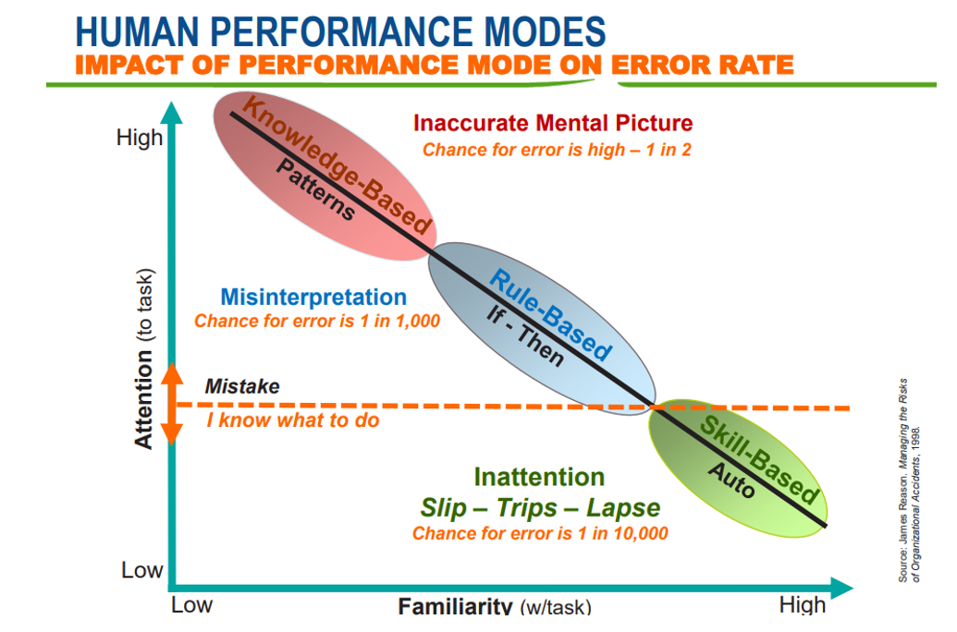

• Skill mode - Actions associated with highly practiced actions in a familiar situation usually executed from memory. Because the worker is highly familiar with the task, little attention is required, and the worker can perform the task without significant conscious thought. This mode is very reliable, with infrequent errors on the order of 1 in every 10,000 iterations of the task.

• Rule mode - Actions based on selection of written or stored rules derived from one’s recognition of the situation. The worker is familiar with the task and is taking actions in response to the changing situation. Errors are more frequent, on the order of 1 in 1,000, and are due to a misrepresentation of either the situation or the correct response.
• Knowledge mode - Actions in response to an unfamiliar situation. This could be new task or a previously familiar task that has changed in an unanticipated manner. Rather than using known rules, the worker is trying to reason or even guess their way through the situation. Errors can be as frequent as 1 in 2, literally a coin flip.

